**Basic Cammands for Linux Terminal**

→APT :

APT is a command-line tool used for managing packages on Linux systems. It retrieves package information and software from trusted sources for installation, updates, and removal. This tool also handles dependencies, ensuring that all necessary packages are installed. It’s mainly used in Debian-based distributions like Ubuntu. The acronym APT stands for Advanced Packaging Tool, which simplifies package management tasks.

→ YUM:

YUM (Yellowdog Updater Modified) is a free, open-source command-line tool used to manage software on Linux systems that use RPM (Red Hat Package Manager). It helps install, update, and remove software packages easily. YUM automatically handles the dependencies, making sure everything needed is installed. Though it's used through the command line, there are other programs that provide a graphical interface for YUM. YUM is commonly used in Linux systems like CentOS, Fedora, and RHEL.

→Wget:

`wget` is a command-line tool that allows you to download files from the internet directly to your current directory. It works in the background, so you can continue other tasks even if you're disconnected from the internet. The name `wget` comes from combining "World Wide Web" and "get," reflecting its purpose of retrieving files from the web. It supports downloading through HTTP, HTTPS, and FTP protocols. `wget` is especially useful for automating downloads or downloading large files.

→gzip tar:

`gzip` and `tar` are commonly used together in Linux to compress and archive files. **Tar** is a tool that groups multiple files or directories into one single archive file, making it easier to manage and transfer. However, this archive is not compressed by default, so **gzip** is used to compress the archive, reducing its size for storage or faster transmission. The result is a `.tar.gz` file, which is both archived and compressed. This combination is frequently used for backup purposes or when sharing large sets of files over the internet. Together, `tar` and `gzip` make handling large files much more efficient.

-

>Rar:

RAR is a proprietary archive file format designed to compress multiple files into a single, smaller file. It supports data compression to reduce file sizes, making it easier to store or transfer large amounts of data. In addition, RAR files offer error correction, helping to recover data if parts of the file are damaged. The format also supports file spanning, allowing large files to be split into smaller parts for easier storage or transfer. RAR files are commonly used for sharing and archiving data efficiently.

show architecture of machine



• show CPU info

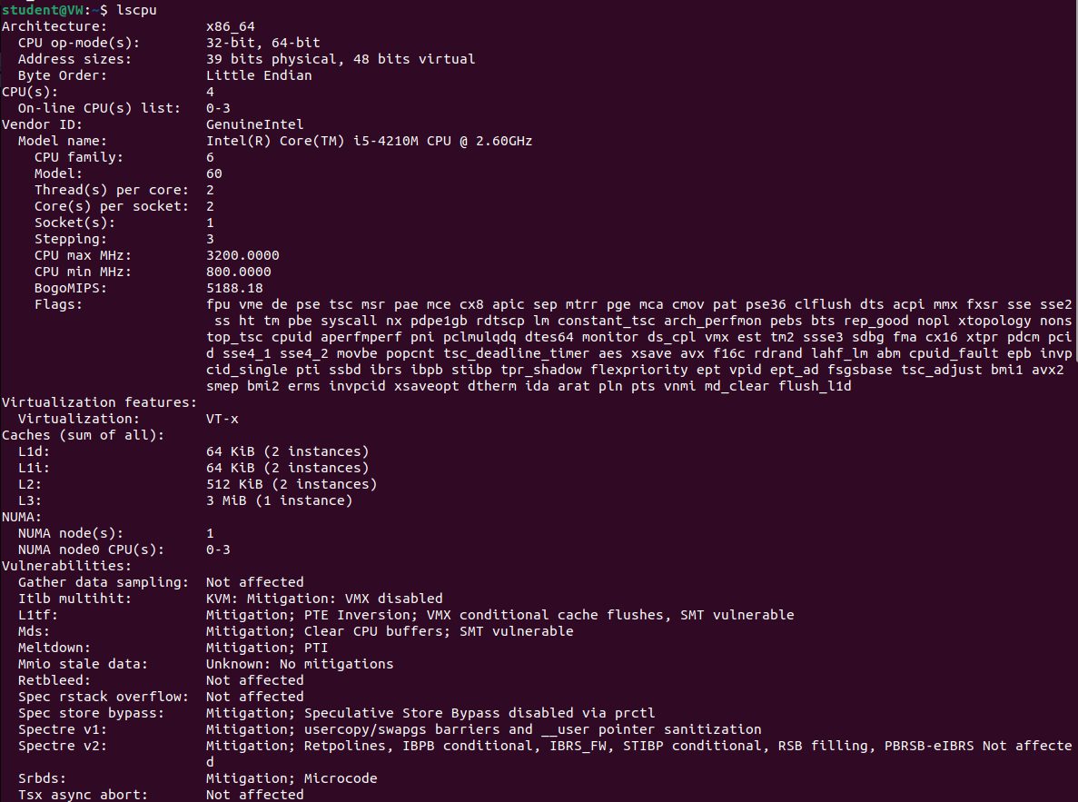

• show version of the kernel



• show system date



• set date and time



• show details of files and directory

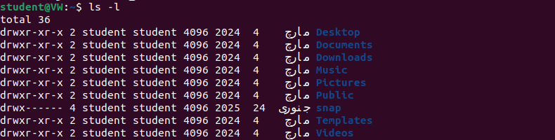

• show hidden files



• show files and directory containing numbers



• create a directory called 'dir1’



• create two directories simultaneously



• show the path of work directory



• delete file called 'file1’

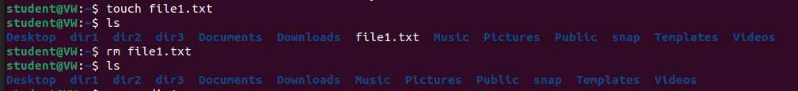

• remove a directory called 'dir1' and contents recursively



• delete directory called 'dir1’



• modify timestamp of a file or directory

